Test Project document
  - WSC2017_TP40_Day2_RU

Submitted by:
Name: External Designer
Member country or region: N/A

Contents
Содержание
This Test Project proposal consists of the following documentation/files:
Конкурсное задание состоит их следующих документов/файлов:
- WSC2017_TP40_Day2_EN.doc
- WSC2017_TP40_Day2_Front and back cover (Folder with images and text) (папка с картинками и текстом)
- WSC2017_TP40_Day2_Articles (Folder with subfolders for spreads) (папка с подпапками для разворотов)
- WSC2017_TP40_Day2_Logo FK (folder with logos) (папка с логотипами)
- WSC2017_TP40_Day2_Mockups (folder with image mock up files) (папка с файлами изображений для макета)

Introduction
Введение
What is #myFKeffect?
Что такое #myFKeffect?
About FK Norway: The main activity of FK Norway is to support the exchange of employees and members between businesses and organizations in Norway, Africa, Latin America and Asia. Through innovative collaboration, our partners share knowledge, learn from each other, and build stronger bonds of cooperation. FK Norway is exclusively financed by the Norwegian National Budget, forms part of the governmental Norwegian developmental policy, and is directly subordinated the Norwegian Ministry of Foreign Affairs.
О компании FK Norway: основная деятельность компании FK Norway связана с поддержкой обмена сотрудниками и членами между бизнесом и организациями Норвегии, Африки, Латинской Америки и Азии. С помощью инновационных технологий сотрудничества наши партнеры обмениваются знаниями, учатся на опыте друг друга и поддерживают взаимосвязи. FK Norway финансируется из Национального бюджета Норвегии; компания влияет на норвежскую государственную политику по развитию и напрямую подчиняется министерству иностранных дел Норвегии.

Description of project and tasks
Описание проекта и заданий
My FK effect (#myFKeffect) is a project aiming at telling former and current FK participants stories about their experiences of being on exchange. This includes personal stories, societal experiences and reflections on how working and living in another country have changed or influenced their lives. Through these stories, we want to highlight and promote the great work our FK participants and partner organizations are doing. We make the world a smaller and a better place.
“Мой эффект FK” (#myFKeffect) это проект, в котором бывшие и текущие участники проекта FK рассказывают истории своего опыта международного обмена. Эти истории включают в себя личные истории, опыт пребывания в другом обществе и истории о том, как работа и жизнь в другой стране изменила или повлияла на их жизнь. С помощью таких историй мы хотим показать какую замечательную работу проделывают участники и партнеры программы FK. Мы улучшаем мир и сближаем его.

Target group:
Young professionals and volunteers from age 18-35. Adventurous, enjoy travelling, interested in social and political problems. Most of them are enrolled or have finished higher education.
Целевая аудитория:
Молодые профессионалы и волонтеры от 18 до 35 лет. Любят приключения, обожают путешествовать, интересуются социальными и политическими вопросами. Большинство из них имеют или получают высшее образование.

Instructions to the Competitor
ИНСТРУКЦИИ ДЛЯ УЧАСТНИКА
Create a folder on your Desktop called YY_MOD_Day2 (where YY represents the number of your workstation).
На рабочем столе создайте папку под названием YY_MOD_Day2 (где YY это номер вашего рабочего места)
This folder structure will be as follows:
Структура папкок:
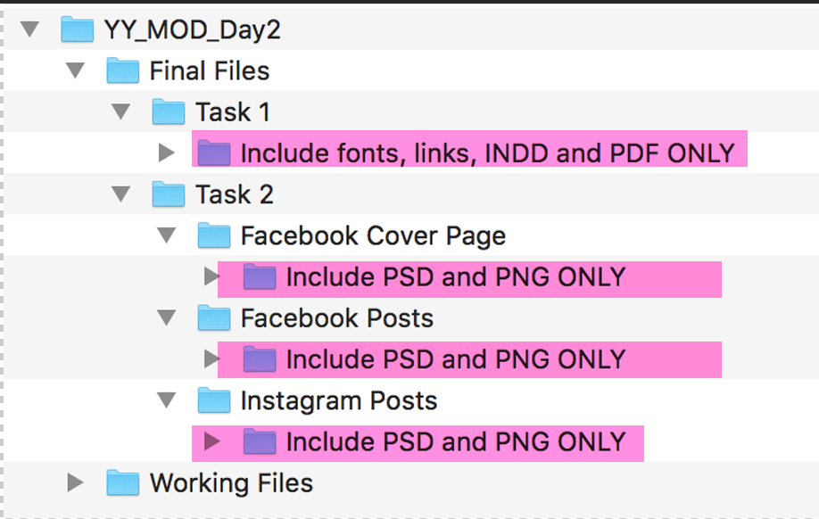
*The pink highlighted text are instructions only
*Выделение розовым только в качестве инструкций
You must include your workstation number on the presentation board and printouts for marking and delivery to your workstation (the number should be included outside of the artwork area)
Включайте номер рабочего места на пенокартоне и распечатках для оценки и доставки работ до вашего места (номер должен находиться вне вашей работы)
Please note: Use a pdf when printing your proofs! The working files will be large and will take too long to print!
Обратите внимание: используйте фацл pdf для печати!

Task 1: Magazine layout
These are sample pages of a new magazine which you need to prepare so that somebody else may produce the rest.
Working File Format: Indesign
Final File format: PDF/X-4:2008 (Including crop marks and document bleed settings)
Magazine name: #myFKeffect
Size: A4, 8 pages.
Bleed: exactly 3mm (if needed)
Text: must include Paragraph styles for body text, title and header,
There can be no overrides.
Page numbers and front cover text do not require a style.
Additional styles may be included. Delete any incoming styles, leaving only yours in the panel.
Name the styles:
BODY
TITLE
HEADER

Each article/spread must include a header containing the person’s name and image (portrait) of the person.
Master pages must include automatic page numbers and any additional design elements you see as appropriate.
The cover and each article (spread) must include an image collage (montage) with at least three images. You must ensure the quality of the colour levels (including contrast and light, so that the images show detail in the shadow areas). Each Image collage must be in one psd file with layers included (do not flatten)
Resolution of image collages in magazine: 230–260ppi (placed at 100% in Adobe InDesign)
ICC profile of image collages: Adobe RGB 1998

Front cover:
Logo - WSC2017_TP40_Day2_Logo FK
#myFKeffect
Text for front cover provided in folder WSC2017_TP40_Day2 front and back cover
No paragraph styles on cover.
Image collage in one psd file with layers including 3 images minimum from primary_images folder
You can add more images from additional_images folders of both cover and articles.
No page number required.

Back cover:
You can design this in any way you like.
No page number.

Inside pages:
Pages 2-3: Infographic and introduction. (Subfolder: Page 2-3 Infographics and introduction)
Map and all text must be included. You may create any other elements you need. You may edit the map.
Pages 4-5: Article with image collage including a minimum of 3 images from primary images folder (subfolder: Page 4-5 Article1)
Pages 6-7: Article with image collage including a minimum of 3 images from primary images folder (subfolder: Page 6-7 Article2)
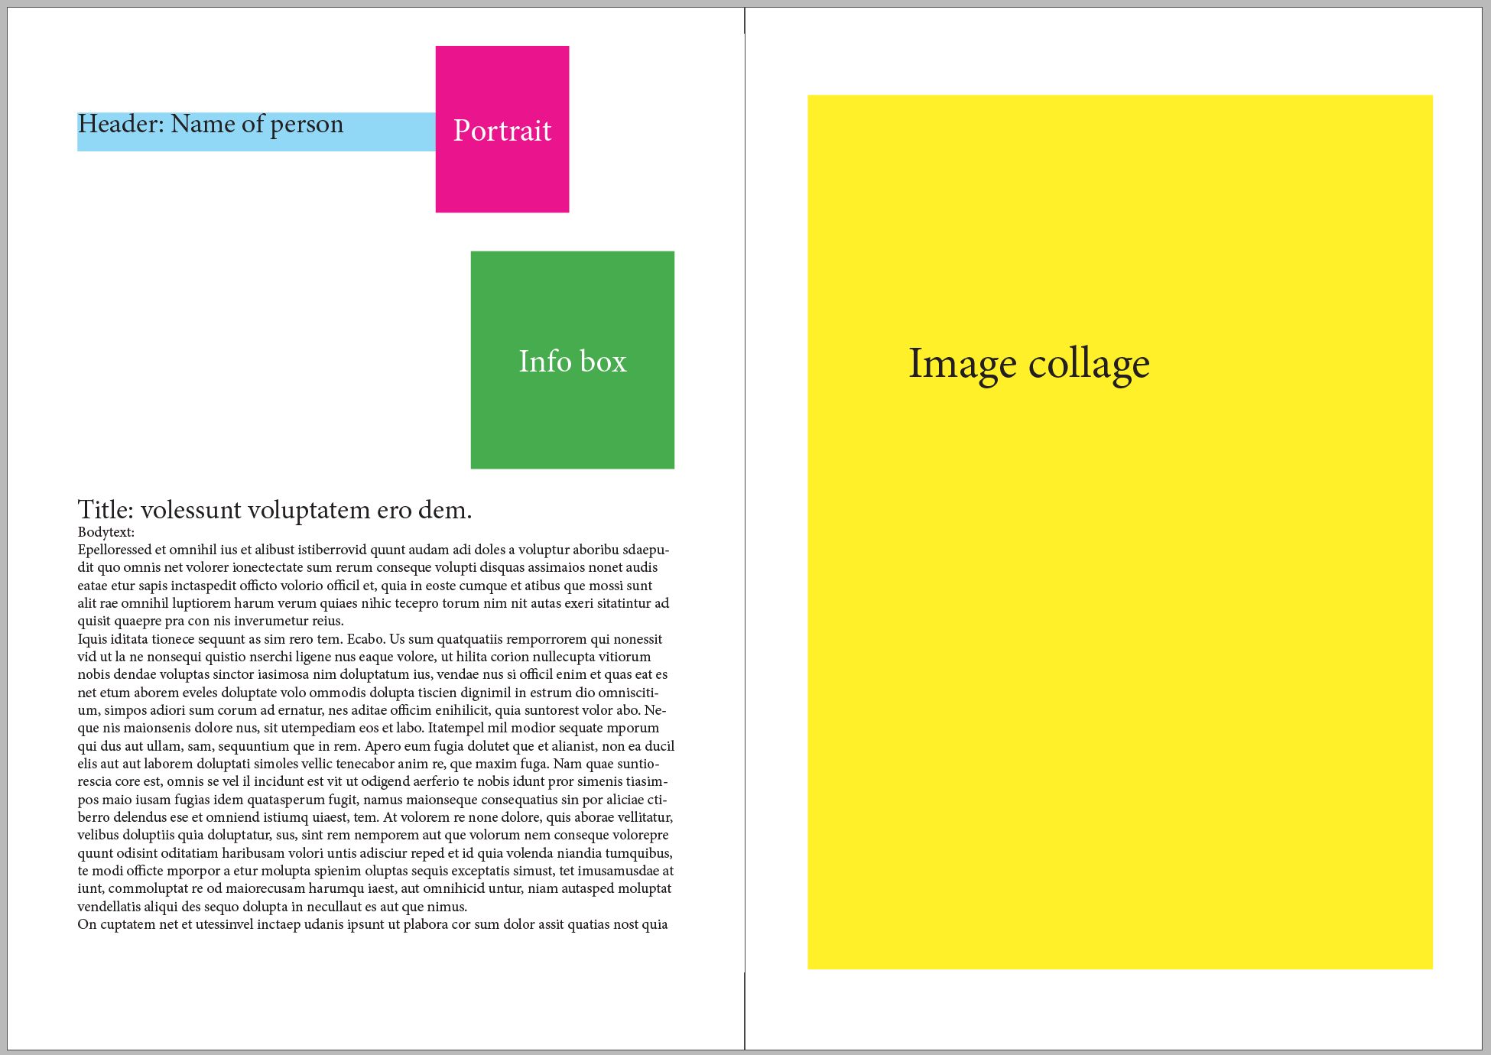
*This is a basic example of the required elements for each spread

All text in the files must be used, you may add additional text.
The text files for the articles have an INFOBOX which you must make a design for. You can place this box anywhere you like.
The image collage styles can be completely different from page to page, they do not need to match. You may create your own background textures, illustrations or other additional design elements.

Name your final files YY_magazine.indd and YY_magazine.pdf (YY is your competitor number).

You must deliver:
1 mock-up of magazine (booklet), folded and trimmed to size – printed at 85% (stapling is not required)
1x INDD, 1 x PDF, Links, Fonts & Working files

Task 2:

Facebook & Instagram Posts
You will need to create a Facebook Post and Instagram Post for each collage
(2 Facebook Posts and 2 Instagram Posts from the two articles).
You need to choose a suitable crop that retains (keeps) the same impact as the magazine version,
and that still makes sense within the requested size. Remember the target group.
The image posts are to be image based only, no text can be included.
Facebook Post size: 1200 x 630 px
Resolution: 126 ppi
ICC profile: Adobe RGB 1998
Working File Format: psd (with layers)
Final File format: png (flattened)
Name your files YY_Facebook1 and YY_Facebook2
Instagram size:1080 x 1080 px
Resolution: 126 ppi
ICC profile: Adobe RGB 1998
Working File Format: psd (with layers)
Final File format: png (flattened)
Name your files YY_Insta1 and YY_Insta2

- Each Instagram collage must be mocked up onto the “INSERT IMAGE HERE” layer in the “iPhone_6_MOCKUP.psd” file
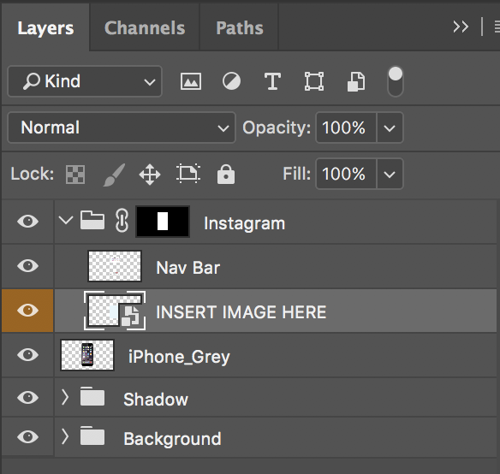
Only the printout is required, but you may save the file in the Instagram folder called YY_Instagram_mockup.psd

Facebook page — cover ImAGE
1 Facebook cover image.
Size: 828 x 315 px
Resolution: 126 ppi
ICC profile: Adobe RGB 1998
Working File Format: psd (with layers)
Final File format: png (flattened)
This should match the style of the magazine cover.
The Facebook cover image is to be image based only, no text can be included.
The Facebook cover image must be mocked up onto the “Facebook_Cover_MOCKUP.psd” file.
Name the files YY_Facebook_Cover and YY_ Facebook_Cover_MOCKUP
Only the printout is required, but you may save the mockup in the Facebook Cover Page folder

You must deliver:
- 1 x printout on A4 of the Facebook post images (include both posts on the same A4 page)

- Mounted together on ONE mounting board (mounting board may be trimmed):
- 1 printout of magazine front cover at 100% trimmed to A4
- 1 printout on A4 of the mocked-up facebook cover image, trimmed to image edge
(reduce to fit on A4)
- 1 printout on A4 of the mocked-up instagram images (two phones side-by-side)
(No trim needed)

5 x PSD, 5 x PNG & Working files (you may include additional files)

Textfile: DAY2_Text frontcover

Logo FK

Text front cover:
#myFKeffect
Issue 1
November 2017

A life changing experience

www.fredskorpset.no
-------------------------------------------

Textfile: page 2-3 infographic

Infographic:

8977 participants has travelled so far

71 projects with active participants

Projects in 24 countries:
Bangladesh
Brazil
Burundi
Cambodia
China
Colombia
Ethiopia
Guatemala
India
Kenya
Madagascar
Malawi
Mozambique
Myanmar (Burma)
Nepal
Nicaragua
Norway
Rwanda
South Africa
Tanzania
Uganda
Vietnam
Zambia
Zimbabwe

- Participants 2016: 543
2016 |  | Percent
Profesionals health and education- North-South | 96 | 18 %
Profesionals health and education - South-South | 111 | 21 %
Civil society/Volunteer | 336 | 61 %
 | 543 | 100 %

--------------

Textfile: page 2-3 My FK effect introduction

Paragraph Style: Title
What is #myFKeffect

Paragraph Style: Body
My FK effect is a project aiming at telling former and current FK participants stories about their experiences being on exchange. This includes personal stories, societal experiences and reflections on how working and living in another country have changed or influenced their lives. Through these stories, we want to highlight and promote the great work our FK participants and partner organizations are doing. We make the world to a smaller and better place.
Paragraph Style:Title
About FK Norway

Paragraph Style: Body
The main activity of FK Norway is to support the exchange of employees and members between businesses and organizations in Norway, Africa, Latin America and Asia. Through innovative collaboration, our partners share knowledge, learn from each other, and build stronger bonds of cooperation. FK Norway is exclusively financed by the Norwegian National Budget, forms part of the governmental Norwegian developmental policy and is directly subordinated the Norwegian Ministry of Foreign Affairs.

--------------

Textfile: text page 4-5

Paragraph Style: Header (This is Name of Person, and should be with PORTRAIT)
#myFKeffect – Ly Bui

Paragraph Style: Title
Participating in the FK exchange programme is an eye-opening experience for me

Paragraph Style: Body
Ly Bui has been on exchange in Kathmandu for almost eight months. For her, the most significant lesson is how different regions, cultural values and social norms deeply influences people’s health practices. This makes it different and challenging to work in Nepal compared to her home country, Vietnam. She has to take various factors into account when designing and implementing health programmes.
Project: Improving Health of low income women in Nepal and for Vietnam
Partners: Integrated Rural Health Development Training Centre (IRHDTC) and Life Centre
FK participant: Bui Thi Phan Ly from Ho Chi Minh city, Vietnam, age 30.
Exchange: Vietnam and Nepal
Year: 2017

“I have become more culturally sensitive and more open-minded when working with communities. I know to appreciate what I have and how to work more effectively in a team”, says Ly when she describes her most prominent #myFKeffect.
Ly has met some challenges during her exchange. When visiting projects in remote parts of Nepal she witnessed how people struggle to meet basic needs. Many people stress to provide food, shelter and medicine for their families. This is something most people take for granted, Ly says. She believes that to end poverty, education and women empowerment is the key.
During her exchange, she has learned several beneficial skills she can use in the future. Except from enhancing her skills on writing research proposals, collecting data and writing reports, she has learned how determinants of health factors impacts people’s lives. She wants to use this knowledge when she goes back to Vietnam to design and implement effective health programs.
The project aims to improve the maternal health of poor rural women in Nepal and Vietnam. They are also striving to improve reproductive health for female factory workers, prevent HIV transmission among men having sex with men and provide support to people living with HIV. In a country like Nepal, where about 25% of the population still live in extreme poverty and the caste system is highly present, women empowerment is limited. Therefore, this project is not only exiting, but vitally important to achieve development.
Ly’s advice to young people who want to go on exchange, is not to be afraid of stepping out of your comfort zone! She also emphasizes the importance of staying positive, have a non-judgmental attitude and to be genuine in all your pursuits. “If you have a passion, try your best to pursue it. No matter how hard your situation might be, you either achieve your goal or learn something from it”.

--------------

Textfile: text page 6-7

Paragraph Style: Header (This is Name of Person, and should be with PORTRAIT)
#myFKeffect – Marte Steiro

Paragraph Style: Title
It is important to respect and accept

“My exchange has made me understand individual differences, qualities and experiences that makes us who we are, and that, essentially, people need people”

Paragraph Style: Body
“It is important to respect and accept other people, cultures and environments to be able to add value to your own life”, says Marte Steiro from Lier, Norway. Currently in Harare, Zimbabwe, Marte is participating in the programme Young Advocates for Change 2017 (YAC). Working at YAC gives her an opportunity to use her leadership skills to engage in advocacy work at community level. This way arenas for young people are created to freely discuss issues that affects them and to feel empowered. Marte delivers training and reaches out to new members and stakeholders.
Name: Marte Steiro
From: Lier, Norway
Age: 25
Place of exchange: Harare, Zimbabwe
Project: Young Advocates for Change
Year: 2017
The programme offers personal development and life-changing experience to the participants as well as supporting African communities to make positive changes for young people. It is based on the African Alliance of YMCA’s philosophy of Subject 2 Citizen (S2C). The S2C initiative is designed to unlock the potential of young people and equip them with the skills and confidence to transform themselves and other young people.
Marte holds a degree in Development and African Studies. With this exchange programme she believes she is one step closer to her goal - a career within the development sector. Her exchange has given her a better understanding of individuals and diversity, conflict management skills and the value of team work.
This experience has been life changing for Marte. Her advice to young people who want to go on an exchange programme is to believe in yourself, your commitment, courage and confidence. Believe that the positive change is achievable. Believe that you can develop and train others to change. “And that we together can change the future of our communities, countries, continents and the world.”

What is your #myFKeffect?

